ASEN 2012 Bottle Rocket Design Project 2

ASEN 2012 Student 177[1]

**A Bottle Rocket Design Project has been created in order to develop an understanding of the dependence of a bottle rocket’s flight on four parameters: initial pressure of air, launch angle, drag coefficient, and initial mass of water. Using MATLAB, these parameters were analyzed using the given equations to predict the launch trajectory and thrust profile of the bottle rocket. The aforementioned parameters were then analyzed to determine their affect on the flight of the bottle rocket, and to achieve a flight distance of 75 meters.**

1. **Nomenclature**

$C_{d}$ = discharge coefficient

*g* = acceleration due to gravity

${}_{air,amb}$ = ambient air density

$v_{bottle}$ = volume of empty bottle

$γ$ = ratio of specific heats for air

$ρ_{water}$ = Density of water

$m_{R}$ = mass of the rocket

$a$ = acceleration of the rocket, with a vector component in the x and z direction

*D* = Drag, with a vector component in the x and z direction

*T* = Thrust, with a vector component in the x and z direction

*h* = heading of the rocket

*q*= dynamic pressure

$m_{air}$ = mass of air in the bottle

$P_{air}$ = Initial Pressure inside the bottle

$T_{air}$ = Initial Temperature inside the bottle

$\dot{m}$ = Mass flow rate out the throat of the bottle

$V_{e}$ = Velocity of the exhaust

$A_{t}$ = Throat Area

$P_{a}$ = Ambient Pressure

*t*= Time

$m_{B}$ = mass of the empty bottle

$P_{end}$ = Pressure at the time all water expelled

$T_{end}$ = Temperature at the time all water expelled

$P_{c}$ = Critical Pressure

$M_{e}$ = Mach exit

$V_{exit}$ = Exit Velocity

$θ$ = launch angle

*Vi*= Initial velocity (0)

$D_{Throat}$ = diameter of the throat

$D_{Bottle}$ = diameter of the bottle

$R$ = gas constant of air

$x_{0}$ = Initial Horizontal Distance

$y_{o}$ = Initial Vertical Distance

$l_{s}$ = Length of test stand

1. **Introduction**

For the purposes of this project, certain parameters are analyzed computationally to understand the workings of a bottle rocket. The main purpose of this project is to develop a functional understanding of the dependence of bottle rocket flight on design parameters such as initial mass of water, launch angle, initial air pressure, and drag coefficient, in order to prepare for the Bottle Rocket lab in ASEN 2004. A MATLAB code was developed using a set of verification case variable values to simulate flight and find a set of parameters that would result in the rocket landing within 1 meter of a 75 meter target.

The trajectory of a bottle rocket stems from Newton’s laws of motion. Looking at motion in two dimensions (horizontal = x and vertical = z) the sum of the forces is given by:

$$\sum{Forces}=\overset{⃑}{F}-\overset{⃑}{D}+\overset{⃑}{g}$$ where drag force is given by:

$$D= \frac{ρ_{a}}{2}V^{2}C_{D}A_{B}$$ Applying the laws of thermodynamics, the initial mass of the rocket, given by:

$$m_{air}=\frac{p_{air}v_{air}}{RT_{air}}$$ will help give a starting point for the mass of the rocket before water and air are expelled out of the throat. Thrust occurs in two phases: 1. Before water is exhausted and 2. After water is exhausted.

During phase one, the mass of the air is held constant, but its volume increases as water is expelled, leading to an inverse relationship between air volume and air density. During flight air flow and expansion are assumed to be isentropic and frictionless, allowing the use of isentropic relations.

$$\frac{P}{P_{air}}={(\frac{v_{air}}{v})}^{γ}$$ In order to find thrust in this phase, mass flow rate is calculated using:

$$\dot{m}=C_{D}ρ_{W}A_{t}V_{e}$$ With the assumption that water is incompressible, Bernoulli’s equation yields an exhaust velocity of: $$V_{e}=\sqrt{\frac{2\left(p-p_{e}\right)}{ρ_{w}}}$$

Resulting in a thrust equation which is independent of liquid density:

$$F=\dot{m}V_{e}=2C_{d}\left(p-p_{a}\right)A_{t}$$

Another factor to be considered is the rate of volumetric flow, calculated within the ODE function, ending when all of the water has been expelled.

$$\frac{dv}{dt}=C_{d}A_{t}\sqrt{\frac{2}{ρ_{w}}\left[P_{0}{\left(\frac{v_{0}}{v}\right)}^{γ}-P_{a}\right]}$$

${\dot{m}}_{R}=-\dot{m}=-ρ_{w}C_{d}A_{t}V_{e}=-C_{d}A_{t}\sqrt{2ρ_{w}\left(P-P_{a}\right)}$ will be integrated to find initial mass of the rocket:

$$m_{R}=m_{B}+m_{air}+m_{water}$$

For the second phase, after the water is expelled, the volume of air remains constant but its mass decreases, therefore the density is proportional to the mass:

$P_{end}=P_{air}{\left(\frac{v_{air}}{v_{B}}\right)}^{γ} ,$ $T_{end}=T_{air}\left(v_{air}\right)$

Critical pressure is defined as $P_{c}=P{\left(\frac{2}{γ+1}\right)}^{γ\left(γ-1\right)}$. If $P_{c}$ > $P_{a}$, the flow is choked and the exit velocity is $V_{e}=\sqrt{γRT_{e}}$. If $P_{c}≤$ $P_{a},$ the flow is not choked, and the exit velocity is $V_{e}=M_{c}\sqrt{γRT_{e}}$. With these conditions for pressure and exit velocities, thrust for both cases is given by: $F={\dot{m}}_{air}V_{e}+\left(P_{c}-P_{a}\right)A_{t},$ and total rocket mass decreases at a rate given by: ${\dot{m}}_{R}=-\dot{m_{air}=-C_{d}ρ_{e}A_{t}V_{e}}$. The final part of the rocket’s flight is the ballistic (free fall) phase. Once the air pressure in the bottle falls to the ambient pressure, the thrust is zero and the rocket falls under the influence of gravity.

1. **Methodology**

The bottle rocket flight consists of three distinct phases: before water is exhausted, before all air is exhausted, and the ballistic phase with no thrust. In MATLAB, a main script was written to call a separate ODE function. Both were developed using the given verification test case. Both codes were started by defining all test case variables with their given values. In the first phase, pressure and mass flow must be solved. Therefore, with thrust given by $F={\dot{m}V}_{e}+\left(P_{e}-P_{a}\right)A_{t}$ and $P_{e}=P_{a},$ the thrust equation for the first phase becomes $F=\dot{m}V_{e}$, with exhaust velocity given by Bernoulli’s equation. The ODE function solves for the thrust F, the horizontal distance x, and vertical distance z. In phase 2, the air expulsion stage, the function solves for the pressure at the end of the phase ($P_{end}$) and the Temperature at the end of the phase $(T_{end})$. Because air expands isentropically, the pressure at any time t is given by: $\frac{P}{P_{end}}={\left(\frac{m_{air}}{{m_{air}}^{i}}\right)}^{γ},$ and the and the critical pressure determines which case the code goes into. The first case, $P_{c}≤P_{a},$ means that the flow is not choked, and the exit Mach number is given by: $\frac{T}{T_{e}}=\left(1+\frac{γ-1}{2}{M_{e}}^{2}\right)$ $\frac{P}{P_{a}}={\left(1+\frac{γ-1}{2}{M_{e}}^{2}\right)}^{\frac{γ}{γ-1}}$ and $V_{e}=M_{c}\sqrt{γRT_{e}}$. In the other case, $P_{c}>P_{a}$, the flow is choked, giving an exit Mach number of 1 and an exit velocity of: $V_{e}=\sqrt{γRT_{e}}$. In phase three, the only forces acting on the bottle rocket are drag and gravity. This is the ballistic phase.

1. **Results**

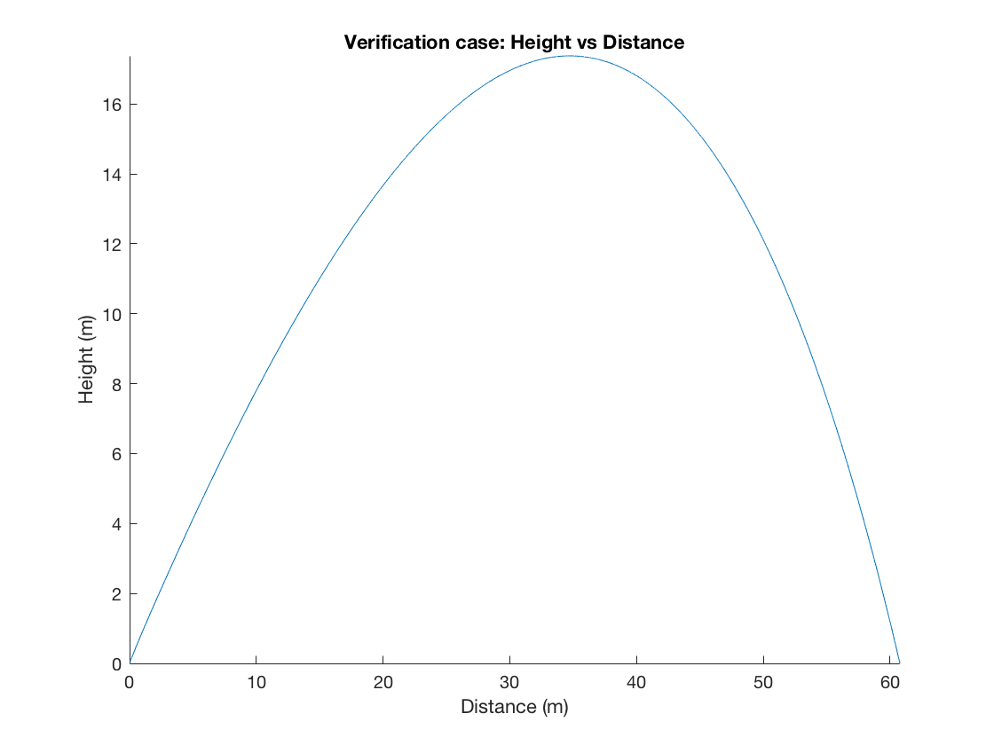For the verification test case, the design parameters are Gauge pressure=344738Pa, Initial water mass=1kg, Drag coefficient=.5, Launch angle = $\frac{π}{4}$. These parameters result in a maximum height and distance of 17.3782m and 60.777m, respectively, and a maximum thrust of 191.0459N, as can be seen in **Figure 1** and **Figure 2**.

**Figure 1: Height vs. distance, both in meters, for test case**

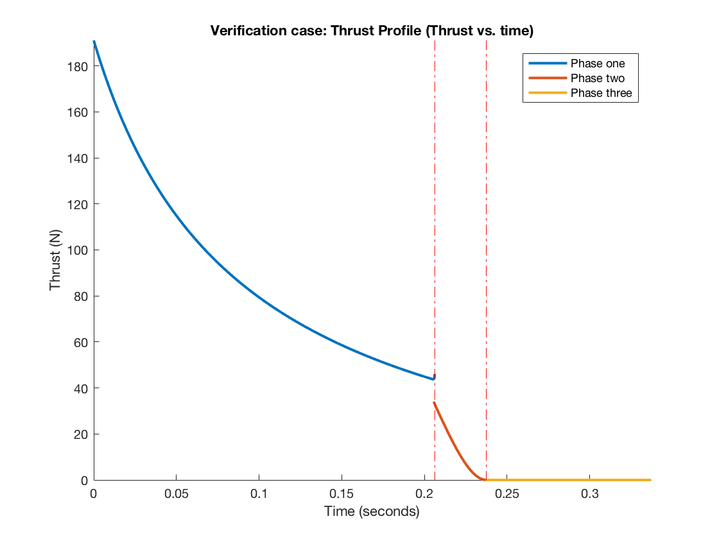

**Figure 2: Thrust(N) vs. time (seconds) for test case**

When gauge pressure was varied, higher gauge pressures were shown to result in higher thrusts, and thus longer maximum heights and distances, as can be seen in **Figure 3.**

|  |  |  |  |  |  |  |
| --- | --- | --- | --- | --- | --- | --- |
| Pg(Pa) | Vwati(m^3) | theta | CD | Distance(m) | Height(m) | Thrust(N) |
| 450000 | .001 | Pi/4 | .5 | 74.2921 | 23.6084 | 249.3796 |
| 400000 | .001 | Pi/4 | .5 | 68.3276 | 20.7930 | 221.6708 |
| 344738 | .001 | Pi/4 | .5 | 60.777 | 17.3782 | 191.0459 |
| 300000 | .001 | Pi/4 | .5 | 53.5287 | 14.3652 | 166.2531 |
| 250000 | .001 | Pi/4 | .5 | 44.0390 | 10.7353 | 138.5442 |

**Figure 3: Design parameters and output results for varied gauge pressure**

When the initial volume of water was varied, thrust remained constant, but the lower mass of water resulted in longer and higher flights, and vice versa for higher mass of water, as can be seen in **Figure 4.**

|  |  |  |  |  |  |  |
| --- | --- | --- | --- | --- | --- | --- |
| Pg(Pa) | Vwati(m^3) | theta | CD | Distance(m) | Height(m) | Thrust(N) |
| 344738 | .0013 | Pi/4 | .5 | 38.2649 | 8.2242 | 191.0459 |
| 344738 | .0012 | Pi/4 | .5 | 48.2749 | 11.7668 | 191.0459 |
| 344738 | .001 | Pi/4 | .5 | 68.3276 | 17.3782 | 191.0459 |
| 344738 | .0008 | Pi/4 | .5 | 66.9228 | 21.0043 | 191.0459 |
| 344738 | .0006 | Pi/4 | .5 | 68.7955 | 22.6397 | 191.0459 |

**Figure 4: Design parameters and output results for varied initial water volume**

When the drag coefficient was varied, thrust was not changed, but the reduced drag resulted in higher and longer flights, and vice versa for increased drag, as can be seen in **Figure 5.**

|  |  |  |  |  |  |  |
| --- | --- | --- | --- | --- | --- | --- |
| Pg(Pa) | Vwati(m^3) | theta | CD | Distance(m) | Height(m) | Thrust(N) |
| 344738 | .001 | Pi/4 | .7 | 48.2736 | 14.4156 | 191.0459 |
| 344738 | .001 | Pi/4 | .6 | 55.9214 | 16.4734 | 191.0459 |
| 344738 | .001 | Pi/4 | .5 | 68.3276 | 17.3782 | 191.0459 |
| 344738 | .001 | Pi/4 | .4 | 66.7869 | 18.4399 | 191.0459 |
| 344738 | .001 | Pi/4 | .3 | 74.4608 | 19.7050 | 191.0459 |

**Figure 5: Design parameters and output results for varied drag coefficient**

When launch angle was varied, thrust was not changed, but lower angles reduced maximum height, while higher angles increased maximum height, but both reduced maximum distance, as can be seen in **Figure 6.**

|  |  |  |  |  |  |  |
| --- | --- | --- | --- | --- | --- | --- |
| Pg(Pa) | Vwati(m^3) | theta | CD | Distance(m) | Height(m) | Thrust(N) |
| 344738 | .001 | 3Pi/8 | .5 | 40.2927 | 28.1714 | 191.0459 |
| 344738 | .001 | Pi/3 | .5 | 48.5942 | 24.4909 | 191.0459 |
| 344738 | .001 | Pi/4 | .5 | 68.3276 | 17.3782 | 191.0459 |
| 344738 | .001 | Pi/6 | .5 | 50.5379 | 7.3710 | 191.0459 |
| 344738 | .001 | Pi/8 | .5 | 41.9288 | 3.8890 | 191.0459 |

**Figure 6: Design parameters and output results for varied launch angle**

Finally, the design parameters were varied with the goal of hitting a target 75 meters away. To accomplish this, all design parameters were held constant, except for gauge pressure, which was increased to 457,000 Pa. This resulted in a maximum height and distance of 23.9998 meters and 75.0551 meters, respectively, and the maximum thrust increased to 253.2589 N, as can be seen in **Figure 7 and Figure 8.**

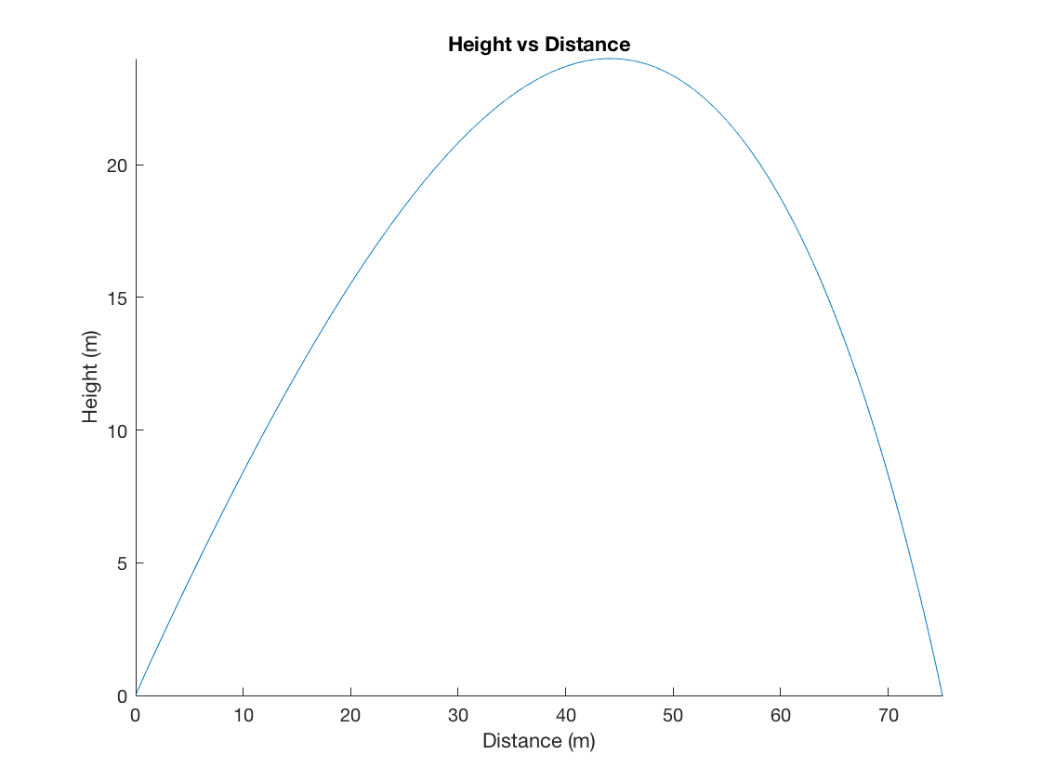

**Figure 7: Height(m) vs Distance(m), to hit the target**

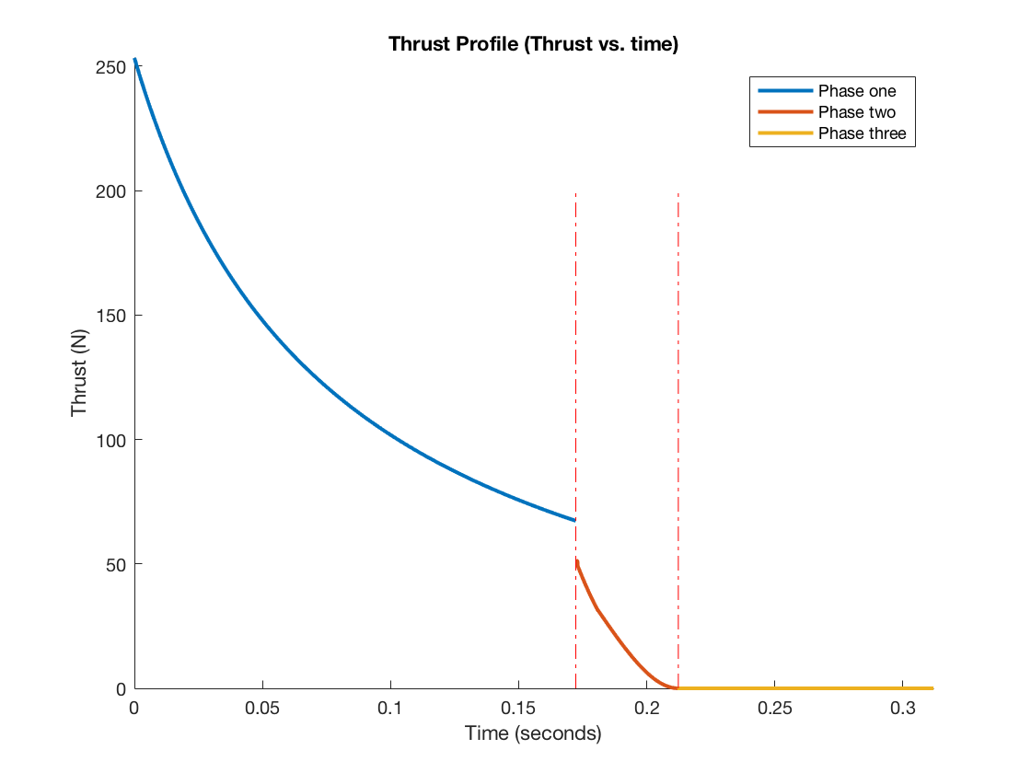

**Figure 8: Thrust(N) vs time(seconds), to hit the target**

1. **Discussion**

As expected, each of the design parameters affected the flight of the rocket in a unique way. Changing gauge pressure increased or decreased the rockets thrust, leading to increased or decreased maximum heights and distances. Changing initial water volume increased or decreased the length of the flight, because a lower initial mass leads to a longer flight, and vice versa. Changing drag coefficient either increased or decreased the length of the flight, because a lower drag coefficient results in lower drag force, and thus a longer flight, and vice versa. Changing launch angle either increased or decreased the maximum height of the bottle rocket’s flight, but always decreased the maximum distance. This makes sense because the original launch angle, $\frac{π}{4}$, is optimal for flight distance.

1. **Conclusion**

For this project, a MATLAB code, consisting of a main script and an ODE function, were developed to model the flight trajectory and thrust profile of a bottle rocket based on a list of verification case variable values, and given equations. There were four design parameters of interest: initial air pressure in the rocket, launch angle, drag coefficient, and initial mass of water inside rocket. Varying each of these parameters affects the flight performance of the bottle rocket in unique ways, and the parameters can

1. **References**

Anderson, L.D., Jr., **Introduction to Flight, 7th Ed.,** McGraw-Hill (2009).

Sutton, G. and Biblarz, O., **Rocket Propulsion Elements, 8th Ed.,** Wiley (2010).

1. **Appendix**

**Engineering Method**

1. **Purpose:** Predict the trajectory and thrust profile of a bottle rocket, and determine the values of certain variables throughout its flight
2. **Given:** Verification test case variables, equations to model flight
3. **Find:** Plots of trajectory and thrust profile
4. **Assume:** Flight only in x and z directions, negligible wind, drag and discharge coefficients are as given
5. **Sketch:** N/a
6. **Principles:** Newton’s second law, Bernoulli’s equation, ODE coding, a bunch of other equations
7. **Alternate Approaches:** If there was an alternate (easier) approach I would have done that. None that I know of
8. **Steps:** See comments in code
9. **Verify:** Used verification test
10. **Reality Check:** All results seem to make sense.

**Flow chart**

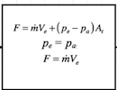

Phase 1

(Water expulsion)

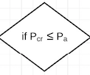

Solve for exhaust velocity using Boernoulli’s

Solve for thrust and find x and z with ODE45

Solve for pressure and mass flow

Phase 2

(Air expulsion)

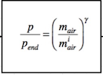

Solve for critical pressure in terms of P

Solve for end pressure and temperature

Phase 3

(Ballistic)

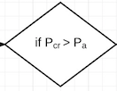

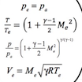

Use ODE45 to solve for increase in x

Drag and gravity only forces acting on rocket

Thrust = 0

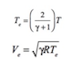

Solve for thrust and find x and z with ODE45

1. ASEN Student, CU Boulder Aerospace